Why Indeed Did the WTC Buildings Collapse?

By Steven E. Jones
Department of Physics and Astronomy
Brigham Young University
Provo, UT 84602

ABSTRACT

In this paper, I call for a serious investigation of the hypothesis that WTC 7 and the Twin Towers were brought down, not just by impact damage and fires, but through the use of pre-positioned cutter-charges. I consider the official FEMA, NIST, and 9-11 Commission reports that fires plus impact damage alone caused complete collapses of all three buildings. And I present evidence for the controlled-demolition hypothesis, which is suggested by the available data, testable and falsifiable, and yet has not been analyzed in any of the reports funded by the US government.

Introduction

We start with the fact that large quantities of molten metal were observed in basement areas under rubble piles of all three buildings: the Twin Towers and WTC7. A video clip provides eye-witness evidence regarding this metal at ground zero: http://plaguepuppy.net/public_html/video%20archive/red_hot_ground_zero_low_quality.wmv . The photograph below by Frank Silecchia shows a chunk of the hot metal being removed from the North Tower rubble on September 27, 2001. Notice the color of the lower portion of the extracted metal -- this tells us much about the temperature of the metal and provides important clues regarding its composition, as we shall see.
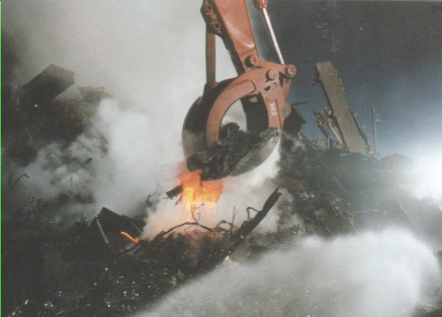
Next, as a basis for discussion, I invite you to consider the collapse of the 47-story WTC 7, which was never hit by a jet. Here is the building prior to and on September 11, 2001:

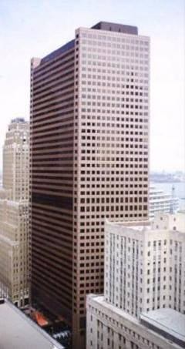
WTC 7: 47 - Story, steel-frame building.
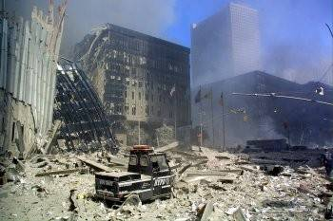

WTC 7 on afternoon of 9-11-01. WTC 7 is the tall
sky-scraper in the background, right. Seen from WTC plaza area.
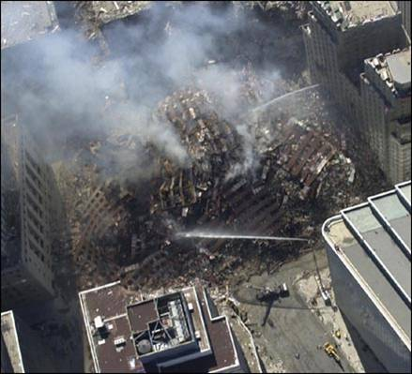
WTC 7 collapsed completely, onto its own footprint

Now that you have seen the still photographs, it is important to the discussion which follows for you to observe video clips of the collapse of this building, so go to:

http://911research.wtc7.net/talks/wtc/videos.html Click on the three photos at the top of this web-site page in order to see the videos of the collapse of WTC 7. It helps to have sound.

Then consider a video close-up of the same building, SW corner, as this corner begins its steady drop to the ground:
http://st12.startlogic.com/~xenonpup/Flashes/squibs_along_southwest_corner.htm

What did you observe?
Symmetry: did the building collapse straight down (nearly symmetrically) – or did it topple over?
Speed: How fast did the southwest corner of the roof fall? (Students and I measure [6.5 +- 0.2] seconds; time it!)
Smoke/debris-jets: Did you observe puffs of smoke/debris coming out of the building? Please note for yourself the sequence and fast timing of observed puffs or “squibs.” Note that reference to web pages is used in this paper due largely to the importance of viewing motion picture clips, thus enhancing consideration of the laws of motion and physics generally. High-quality photographs showing details of the collapses of WTC 7 and the WTC Towers can be found in books (Hufschmid, 2002; Paul and Hoffman, 2004), magazines (Hoffman, 2005; Baker, 2005) and at http://911research.wtc7.net/wtc/evidence/photos/collapses.html .

On the basis of photographic and video evidence as well as related data and analyses, I provide thirteen reasons for rejecting the official hypothesis, according to which fire and impact damage caused the collapse of the Twin Towers and WTC 7, in favor of the controlled-demolition hypothesis. The goal is to promote further scrutiny of the official government-sponsored reports as well as serious investigation of the controlled-demolition hypothesis. (No rebuttal of my argument can be complete, of course, unless it addresses all of these points.)

Thirteen Reasons to Challenge Government-sponsored Reports and Investigate the Controlled-demolition Hypothesis

1. Molten Metal: Flowing and in Pools

There are several published observations of molten metal in the basements of all three buildings, WTC 1, 2 (“Twin Towers”) and 7. For example, Dr. Keith Eaton toured Ground Zero and stated in The Structural Engineer,
‘They showed us many fascinating slides’ [Eaton] continued, ‘ranging from molten metal which was still red hot weeks after the event, to 4-inch thick steel plates sheared and bent in the disaster’. (Structural Engineer, September 3, 2002, p. 6; emphasis added.)

The existence of molten metal at Ground Zero was reported by several observers (see first photograph above), including Greg Fuchek:
For six months after Sept. 11, the ground temperature varied between 600 degrees Fahrenheit and 1,500 degrees, sometimes higher. “In the first few weeks, sometimes when a worker would pull a steel beam from the wreckage, the end of the beam would be dripping molten steel,” Fuchek said. (Walsh, 2002)
Sarah Atlas was part of New Jersey's Task Force One Urban Search and Rescue and was one of the first on the scene at Ground Zero with her canine partner Anna. She reported in Penn Arts and Sciences, summer 2002,
‘Nobody's going to be alive.' Fires burned and molten steel flowed in the pile of ruins still settling beneath her feet. (Penn, 2002; emphasis added.)
Notice that the molten metal (probably not steel alone; see discussion below) was flowing down in the rubble pile early on; so it is not the case that the molten metal pools formed due to subterranean fires after the collapses.
A video clip provides further eyewitness evidence regarding this extremely hot metal at ground zero: http://plaguepuppy.net/public_html/video%20archive/red_hot_ground_zero_low_quality.wmv . The observer notes that the observed surface of this metal is still reddish-orange some six weeks after 9-11. This implies a large quantity of a metal with fairly low heat conductivity and a relatively large heat capacity (e.g., iron is more likely than aluminum) even in an underground location. Like magma in a volcanic cone, such metal might remain hot and molten for a long time -- once the metal is sufficiently hot to melt in large quantities and then kept in a fairly-well insulated underground location. Moreover, as hypothesized below, thermite reactions may have resulted in substantial quantities (observed in pools) of molten iron at very high temperatures – initially above 2,000 °C (3,632 °F). At these temperatures, steel will melt, and aluminum materials from the buildings should continue to undergo exothermic oxidation reactions with materials also entrained in the molten metal pools including metal oxides which will then keep the pools molten and even growing for weeks despite radiative and conductive losses.
Thus, molten metal was repeatedly observed and formally reported in the rubble piles of the WTC Towers and WTC 7, metal that looked like molten steel or perhaps iron. Scientific analysis would be needed to conclusively ascertain the composition of the molten metal in detail.
I maintain that these observations are consistent with the use of high-temperature cutter-charges such as thermite, HMX or RDX or some combination thereof, routinely used to melt/cut/demolish steel. Thermite is a mixture of iron oxide and aluminum powder. The end products of the thermite reaction are aluminum oxide and molten iron. So the thermite reaction generates molten iron directly, and is hot enough to melt and even evaporate steel which it contacts while reacting. Here is the thermite-reaction equation for a typical mixture of aluminum powder iron oxide powder:
2Al + Fe₂O₃ = Al₂O₃ + 2Fe (molten iron), ΔH = − 853.5 kJ/mole.
Thermite contains its own supply of oxygen and so the reaction cannot be smothered, even with water. Use of sulfur in conjunction with the thermite, for example in thermate, will accelerate the destructive effect on steel, and sulfidation of structural steel was indeed observed in some of the few recovered members from the WTC rubble, as reported in Appendix C of the FEMA report. (FEMA, 2002; see also, http://www.911research.wtc7.net/wtc/evidence/metallurgy/index.html.) On the other hand, falling buildings (absent incendiaries such as thermite) have insufficient directed energy to result in melting of large quantities of metal; any particles of molten metal somehow formed during collapse will not coalesce into molten pools of metal!
The government reports admit that the building fires were insufficient to melt steel beams -- then where did the molten metal pools come from? Metals expert Dr. Frank Gayle (working with NIST) stated:
Your gut reaction would be the jet fuel is what made the fire so very intense, a lot of people figured that's what melted the steel. Indeed it did not, the steel did not melt. (Field, 2005; emphasis added.)
None of the official reports tackles this mystery. Yet this is evidently a significant clue to what caused the Towers and WTC 7 to collapse. So an analysis of the composition of the previously-molten metal is required by a qualified scientific panel. This could well become an experiment crucis.
Prof. Thomas Eagar explained in 2001 that the WTC fires would NOT melt steel:
"The fire is the most misunderstood part of the WTC collapse. Even today, the media report (and many scientists believe) that the steel melted. It is argued that the jet fuel burns very hot, especially with so much fuel present. This is not true.... The temperature of the fire at the WTC was not unusual, and it was most definitely not capable of melting steel.
In combustion science, there are three basic types of flames, namely, a jet burner, a pre-mixed flame, and a diffuse flame.... In a diffuse flame, the fuel and the oxidant are not mixed before ignition, but flow together in an uncontrolled manner and combust when the fuel/oxidant ratios reach values within the flammable range. A fireplace is a diffuse flame burning in air, as was the WTC fire. Diffuse flames generate the lowest heat intensities of the three flame types... The maximum flame temperature increase for burning hydrocarbons (jet fuel) in air is, thus, about 1000 °C -- hardly sufficient to melt steel at 1500 °C."
"But it is very difficult to reach [even] this maximum temperature with a diffuse flame. There is nothing to ensure that the fuel and air in a diffuse flame are mixed in the best ratio... This is why the temperatures in a residential fire are usually in the 500 °C to 650 °C range [Cote, 1992]. It is known that the WTC fire was a fuel-rich, diffuse flame as evidenced by the copious black smoke.... It is known that structural steel begins to soften around 425 °C and loses about half of its strength at 650 °C [Cote, 1992]. This is why steel is stress relieved in this temperature range. But even a 50% loss of strength is still insufficient, by itself, to explain the WTC collapse... The WTC, on this low-wind day, was likely not stressed more than a third of the design allowable... Even with its strength halved, the steel could still support two to three times the stresses imposed by a 650 °C fire." (Eagar and Musso, 2001; emphasis added.)
We will return to the question of fire-induced stresses and WTC collapses later.
Even without a direct elemental analysis, we can rule out some metals based on available data. The photograph in the introduction shows a chunk of hot metal being extracted at ground zero. The hottest portion of the chunk is the lower portion, which was deepest down in the slag, and the metal is seen to be yellow-hot, certainly above cherry-red hot. The following table (see http://www.processassociates.com/process/heat/metcolor.htm ) provides data regarding the melting temperatures of lead, aluminum, structural steel and iron, along with approximate metal temperatures by color. Note that the approximate temperature of a hot metal is given by its color, quite independent of the composition of the metal. (A notable exception is aluminum, which due to low emissivity and high reflectivity appears silvery-gray in daylight conditions, at all temperatures whether in solid or liquid forms. Aluminum does incandesce like other metals, but faintly, so that in broad daylight conditions in air, it appears silvery-gray according to experiments done at BYU. [Jones, 2006])
°F °C K
Lead (Pb) Melts | 621 | 327 | 601
Faint Red | 930 | 500 | 770
Blood Red | 1075 | 580 | 855
*Aluminum Melts | 1221 | 660 | 933
Medium Cherry | 1275 | 690 | 965
Cherry | 1375 | 745 | 1020
Bright Cherry | 1450 | 790 | 1060
Salmon | 1550 | 845 | 1115
Dark Orange | 1630 | 890 | 1160
Orange | 1725 | 940 | 1215
Lemon | 1830 | 1000 | 1270
Light Yellow | 1975 | 1080 | 1355
White | 2200 | 1205 | 1480
*Structural Steel Melts | ~2750 | ~1510 | ~1783
*Iron Melts | 2800 | 1538 | 1811
*Thermite (typical) | >4500 | >2500 | >2770

We see from the photograph above that solid metal from the WTC rubble existed at salmon-to-yellow-hot temperature (approx. 1550 - 1900 ºF, 845 - 1040 ºC.) The temperature is well above the melting temperatures of lead, zinc and aluminum, and these metals can evidently be ruled out since they would be runny liquids at much lower (cherry-red or below) temperatures. However, the observed hot specimen could be structural steel (from the building) or iron (from a thermite reaction) or a combination of the two. Additional photographs of the hot metal could provide further information and advance the research.
The following photograph has become available, evidently showing the now-solidified metal with entrained material, stored (as of November 2005) in a warehouse in New York:
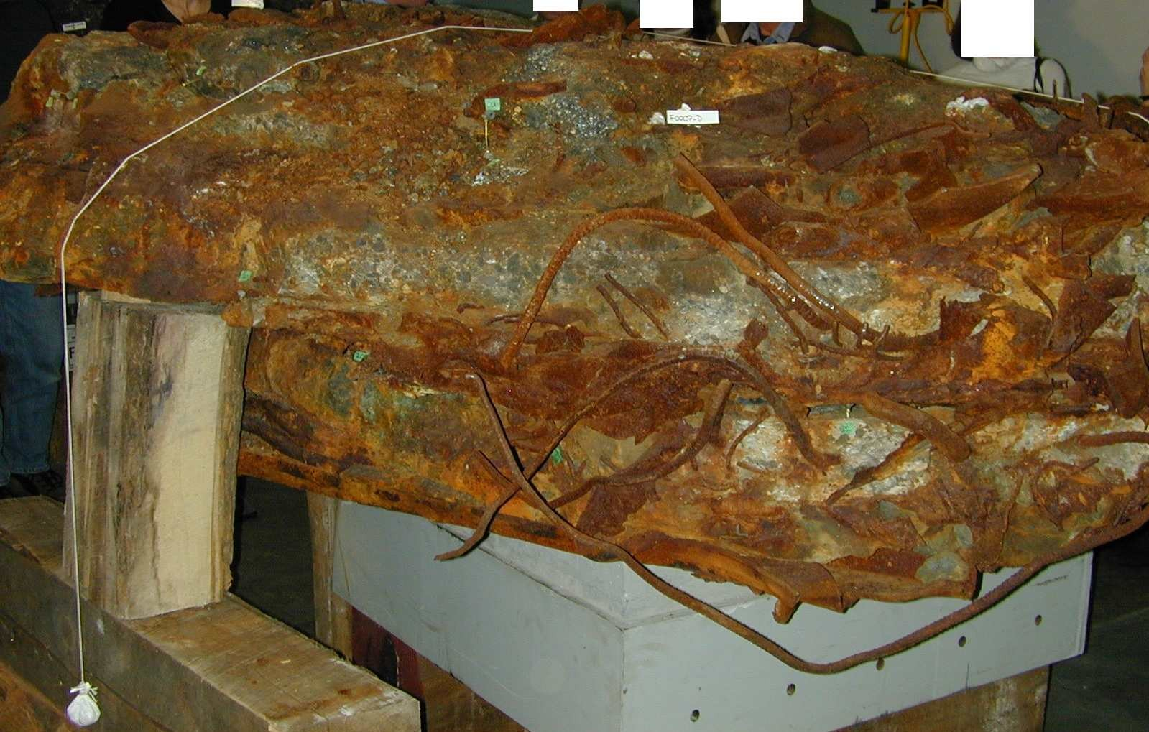
The abundance of iron (as opposed to aluminum) in this material is indicated by the reddish rust observed. When a sample is obtained, a range of characterization techniques will quickly give us information we seek. X-ray energy dispersive spectrometry (XEDS) will yield the elemental composition, and electron energy-loss spectroscopy will tell us the elements found in very small amounts that were undetectable with XEDS. Electron-backscattered diffraction in the scanning electron microscope will give us phase information; the formation of certain precipitates can tell us a minimum temperature the melt must have reached. We will endeavor to obtain and publish these data, whatever they reveal.
An intriguing photograph (below right) taken by Rob Miller, photojournalist with the New York Post, provides additional photographic evidence (Swanson, 2003) for the use of thermite or a sulfur-containing derivative such as thermate. We see debris and dust as WTC 1 collapses, with WTC 7 seen in the foreground, across the street from WTC 1. The next photograph (left), for comparison, the thermite reaction with a grayish-white aluminum-oxide dust plume extending from white-hot molten iron "blob" from the reaction. (Experiment at BYU by the author in which thermite-plus-sulfur cut through a steel cup in a fraction of a second).

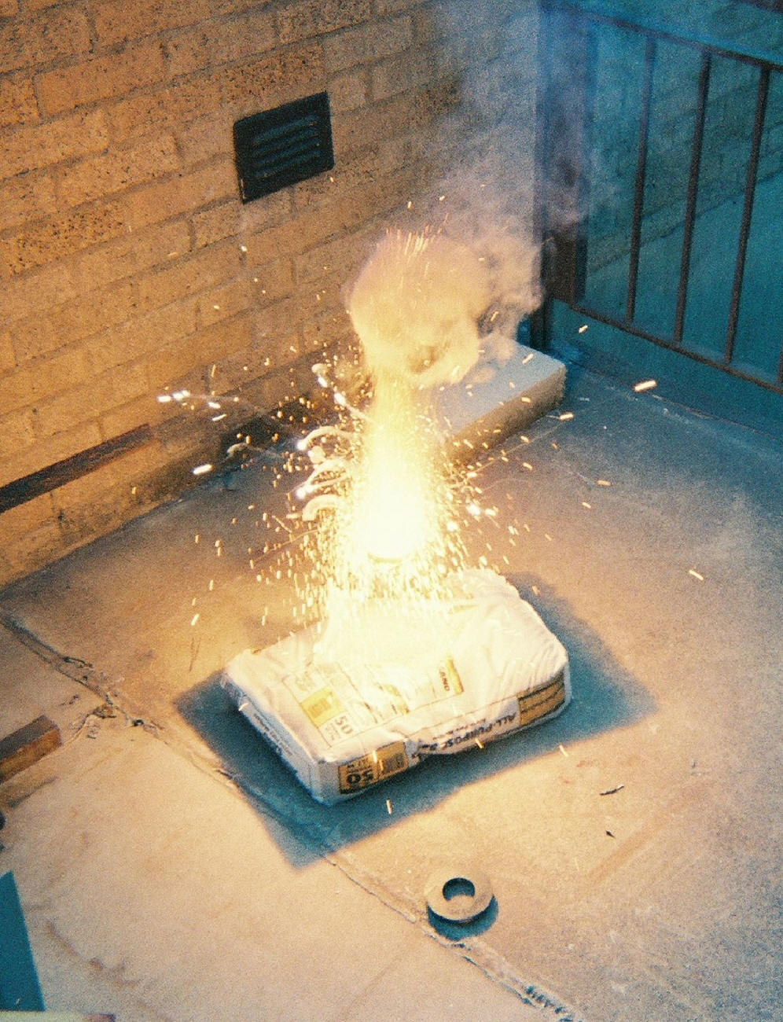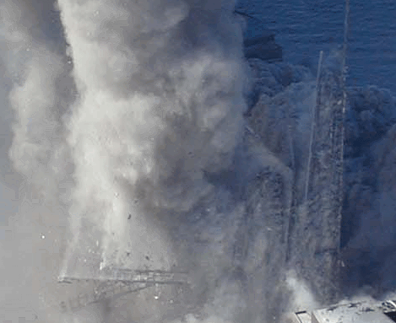
Mr. Miller captured two ladder-like structures in his photograph (lower left of the right-most photograph above; a cleaner photo is being sought), consistent with steel structures observed in the core of WTC 1. Observe the grayish-white plumes trailing upward from white "blobs" at the left-most extremities of the upper structure. (The lower structure is mostly obscured by dust.) It is possible that thermite cut through structural steel and that what we now observe is white-hot iron from the reaction adhering to the severed ends of the steel, with grayish-white aluminum oxide still streaming away from the reaction sites. The observations are consistent with the use of thermite or one of its variants. However, further analysis of this and additional photographs from the series is necessary before any firm conclusions can be drawn about this line of evidence.
Dramatic footage reveals yellow-to-white hot molten metal dripping from the South WTC Tower just minutes before its collapse: http://video.google.com/videoplay?docid=-2991254740145858863&q=cameraplanet+9%2F11. Photographs capture the same significant event, clearly showing liquid metal dropping from the South Tower, still hot as it nears the ground below:
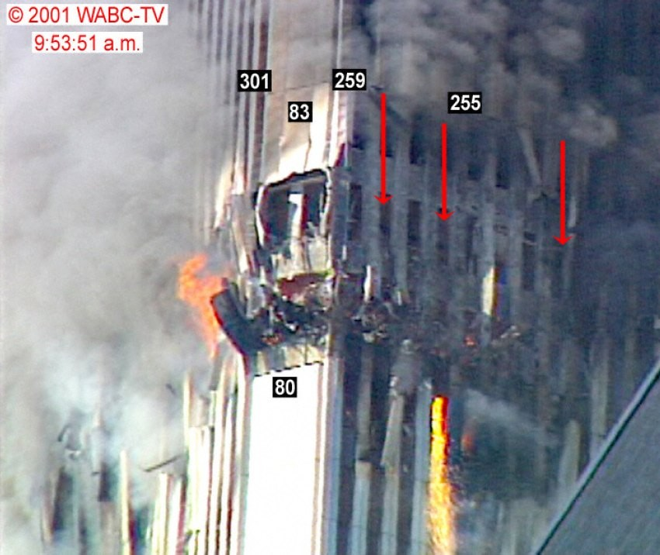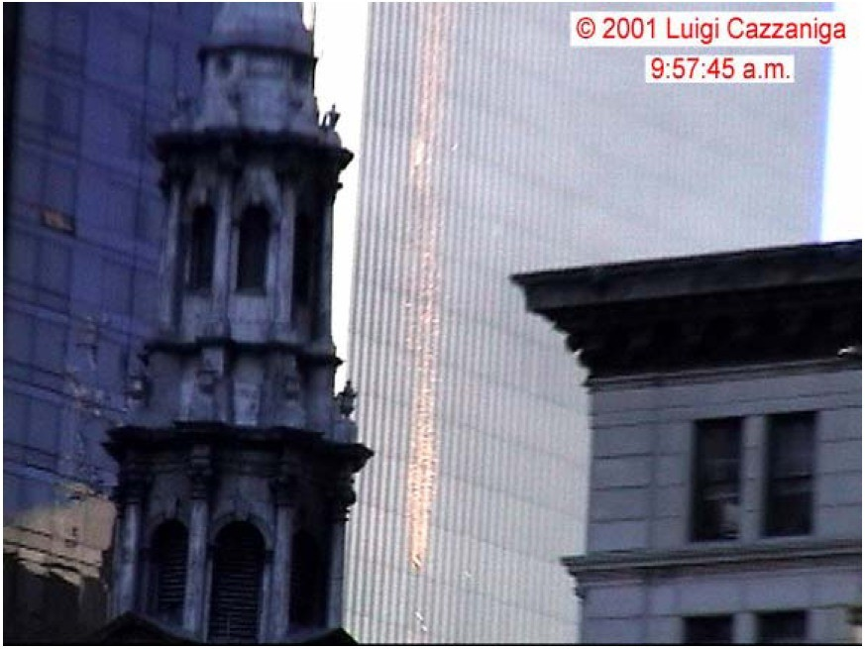
Who can deny that liquid, molten metal existed at the WTC disaster? The yellow color implies a molten-metal temperature of approximately 1000 ºC, evidently above that which the dark-smoke hydrocarbon fires in the Towers could produce. If aluminum (e.g., from the plane) had melted, it would melt and flow away from the heat source at its melting point of about 650 ºC and thus would not reach the yellow color observed for this molten metal. Thus, molten aluminum is already ruled out with high probability. But molten iron with the characteristics seen in this video is in fact consistent with a thermite-reaction attacking the steel columns in the Tower, thus weakening the building just prior to its collapse, since thermite produces molten iron at yellow-to-white hot temperatures. (As some of the molten metal hits the side of the building in the video clip above, the white-hot interior is evidently exposed as the metal "splashes".) Also, the fact that the liquid metal retains an orange hue as it nears the ground (right photograph) further rules out aluminum, and suggests a mid-flight thermite reaction (typical of thermite). The reader may wish to compare the dripping molten metal observed on the corner of the South Tower just before its collapse with the dripping molten metal from known thermite reactions: http://www.checktheevidence.com/911/Thermite2.htm .
If an aluminothermic reaction was indeed used to sever steel columns as strongly suggested by the photos and video above, then along with molten iron, aluminum oxide should be found in unusual abundance and ultra-fine particulate-size in the toxic dust from the collapses of the Towers and WTC 7. We intend to look for these residual end-products, in particular, for iron and entrained aluminum oxide in solidified slag extracted from one of the WTC-molten-metal pools.
Other explanations for the observations are sought, of course. For example, F. Greening has suggested that aluminum from the planes which struck the Towers could melt, and that this aluminum might fall on "rusted steel surfaces inducing violent thermite explosions." [Greening, 2006] So a few students and I did straightforward experiments by melting aluminum and dropping molten aluminum on pre-heated rusted steel surfaces. There were in fact NO "violent thermite" reactions seen. We observed that the temperature of the molten aluminum in contact with the rusty iron simply cooled at about 25 ºC per minute (measured with an infrared probe) until the aluminum solidified, so that any thermite reactions between the aluminum and iron oxide must have been minimal and did not compete with radiative and conductive cooling, thus NOT supporting predictions made by Greening. There was no observable damage or even warping of the steel. (See photograph below.) Nor were violent reactions observed when we dropped molten aluminum onto crushed gypsum and concrete (wet or dry) and rusty steel. [Jones, 2006] These experiments lend no support whatever to the notion [see Greening, 2006] that molten aluminum in the WTC Towers could have destroyed the enormous steel columns in the cores of the buildings, even if those columns were rusty and somehow subjected to direct contact with molten aluminum.
We also noted that while a steel pan holding the aluminum glowed red and then yellow hot, the molten aluminum inside retained its silvery-gray color, adding significantly to the evidence that the yellow-white molten metal dripping from the South Tower shortly before its collapse was NOT molten aluminum. (Recall also that the yellow color of the molten metal (video clip above) implies a temperature of approximately 1100 ºC -- too high for the dark-smoke hydrocarbon fires burning in the building.) This is point worth emphasizing: aluminum has low emissivity and high reflectivity, so that in daylight conditions molten aluminum will appear silvery-gray, while molten iron (with its characteristic high emissivity) will appear yellow-white (at ~1100 ºC) as observed in the molten metal dripping from the South Tower just before its collapse (see http://www.checktheevidence.com/911/Thermite2.htm).

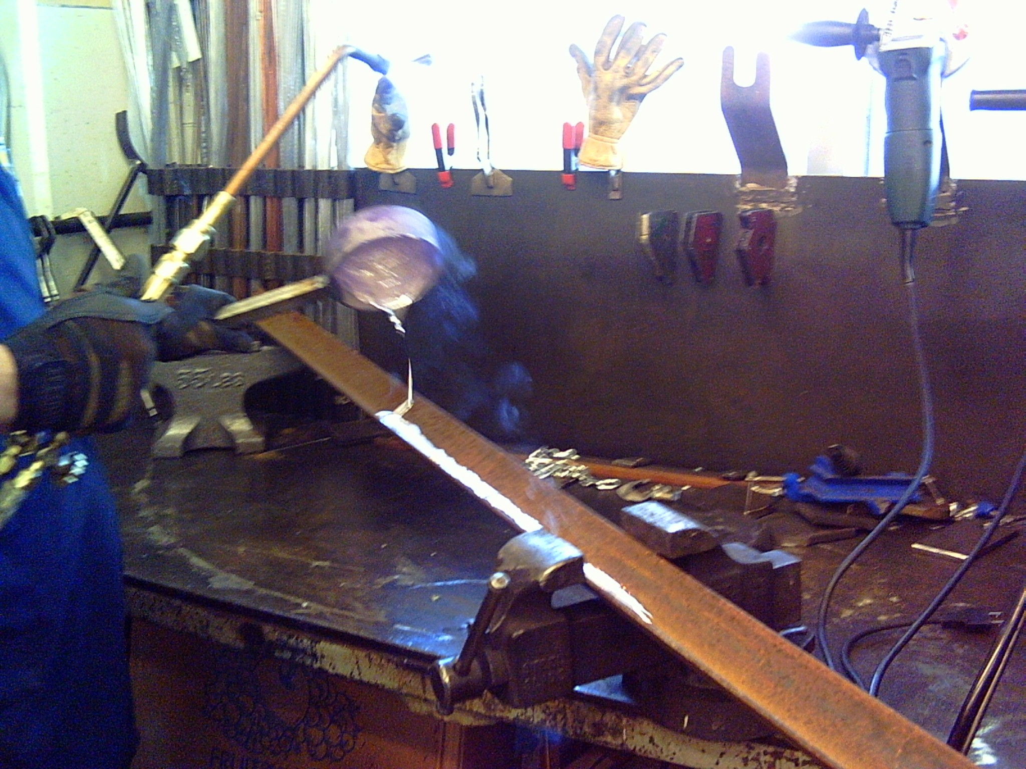
Molten aluminum poured onto rusted steel: no violent reactions observed at all.

Thus, we find substantial evidence supporting the current conjecture that some variation of thermite (e.g., solid aluminum powder plus Fe2O3, with possible addition of sulfur) was used on the steel columns of the WTC Tower to weaken the huge steel supports, not long before explosives finished the demolition job. Roughly 2,000 pounds of RDX-grade linear-shaped charges (which could have been pre-positioned by just a few men) would then suffice in each Tower and WTC 7 to cut the supports at key points so that gravity would bring the buildings straight down. The estimate is based on the amount of explosives used in controlled demolitions in the past and the size of the buildings. Radio-initiated firing of the charges is implicated here, perhaps using Joule heating or superthermite matches. Using computer-controlled radio signals, it would be an easy matter to begin the explosive demolition near the point of entry of the planes in the Towers (to make it appear that the planes somehow initiated the collapse; cutter-charges could have been pre-placed at numerous spots in the building, since one would not know exactly where the planes would enter.)
It is important to note that initiating the thermite reaction requires temperatures well above those achieved by burning jet fuel or office materials -- which is an advantage of using thermite charges over conventional monomolecular explosives such as TNT, RDX and PETN. Below is a photograph of an experiment performed by the author and colleagues at BYU in which a sample of thermite was heated to orange-hot temperature (about 1700 ºF). We demonstrated that the thermite reaction would not ignite at this high temperature. Later, the thermite reaction was triggered by burning a magnesium strip in contact with the thermite. An electrical superthermite "match" could have been used and remotely triggered via radio signal.
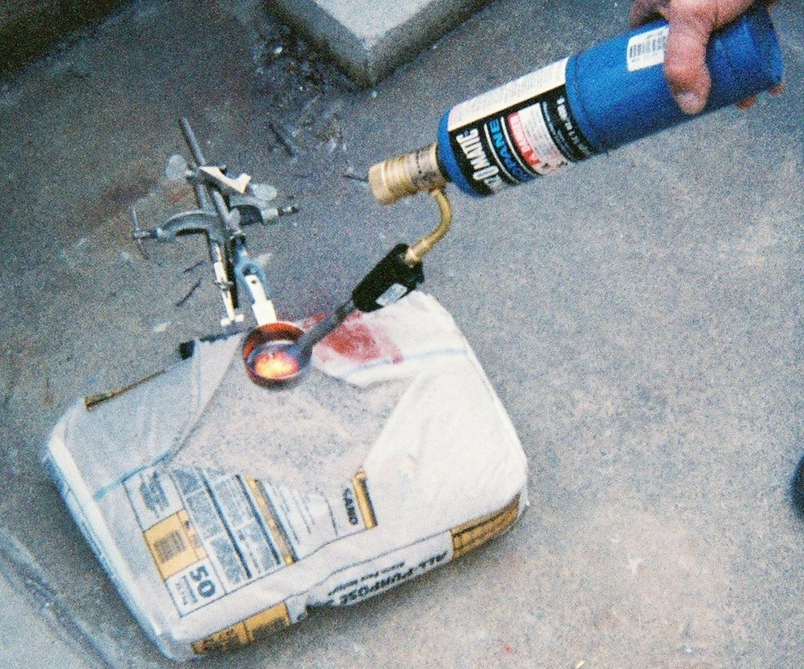
Thermite did not ignite when heated with a propane torch.
"Superthermites" use tiny particles of aluminum known as "nanoaluminum" (<120 nanometers) in order to increase their reactivity. Mixed with fine metal oxide particles such as micron-scale iron oxide dust, nanoaluminum in superthermite becomes explosive:
Nanoenergetics refers to a broad class of energetic materials and formulations that exploit mechanisms and properties that exist only at the nanoscale. For example, aluminum is a highly reactive metal when produced as nanopowder (size <100 nm). Metal powders are an important subset of nanoenergetics. Today it is well known that nanoenergetics can increase performance of explosives, propellants and pyrotechnic devices. The interest and appeal of nanoenergetic formulations lies in their ability to release energy in a controllable fashion, coupled with their higher energy density, relative to conventional organic explosives…. Recent advances in particle synthesis technology allow commercial scale production of nanoaluminum. (See http://www.nanoscale.com/markets_nanoenergetics.asp and, regarding bombs, http://www.technologyreview.com/articles/05/01/wo/wo_gartner012105.asp?p=1 .)
The possible use of nanoaluminum and superthermite on 9/11 should be further investigated.
Are there any examples of buildings toppled by fires or any reason other than deliberate demolition that show large pools of molten metal in the rubble? I have posed this question to numerous engineers and scientists, but so far no examples have emerged. Strange then that three buildings in Manhattan, supposedly brought down finally by fires, all show these large pools of molten metal in their basements post-collapse on 9-11-2001. It would be interesting if underground fires could somehow produce molten steel, for example, but then there should be historical examples of this effect since there have been many large fires in numerous buildings. It is not enough to argue hypothetically that fires could possibly cause all three pools of molten metal.
Furthermore, we have seen published reports that "molten steel [or other metal] flowed in the pile of ruins still settling beneath her feet" -- how could building fires have caused that effect? Has it ever been seen before? We know of no such instances. However, thermite-derivative reactions as conjectured would produce molten flowing iron, as observed.
The very high temperatures (corresponding to salmon-yellow colors) of the molten metal observed in videos and photographs are difficult to explain in the context of the official theory that fires finally caused the collapse of the WTC Towers and WTC 7. Highly exothermic reactions other than jet-fuel or office-material fires, such as the thermite reaction which produces white-hot molten iron as an end product, are clearly implied by the data. In addition, the use of explosives such as HMX and RDX should also be considered. The official reports by NIST, FEMA and the 9-11 Commission strikingly omit mention of large quantities of molten metal observed in the basement areas of WTC 7 and the Towers. The fact that the official reports do not adequately address the issue of molten metal found at the sites provides compelling motivation for continued research on the WTC collapses.

2. Observed Temperatures around 1000°C and Sulfidation in WTC 7 Steel

One of the relatively few previous peer-reviewed papers relating to the WTC collapses provides "An Initial Microstructural Analysis of A36 Steel from WTC Building 7." This brief but important letter states:
While the exact location of this beam could not be determined, the unexpected erosion of the steel found in this beam warranted a study of microstructural changes that occurred in this steel. Examination of other sections in this beam is underway.
ANALYSIS Rapid deterioration of the steel was a result of heating with oxidation in combination with intergranular melting due to the presence of sulfur. The formation of the eutectic mixture of iron oxide and iron sulfide lowers the temperature at which liquid can form in this steel. This strongly suggests that the temperatures in this region of the steel beam approached ~1000°C by a process similar to making a “blacksmith’s weld” in a hand forge. (Barnett, 2001)
How were these ~1000°C temperatures in the steel beam achieved? As noted above in the quotation from Eagar, it is difficult to reach temperatures above 650°C in the type of diffuse fires evident in the WTC buildings, let alone in the steel columns where heat is transported away by the enormous heat sink of the steel structure. So the high temperatures deduced by Barnett, Biederman and Sisson are indeed remarkable.
Then there is the rather mysterious sulfidation of the steel reported in this paper -- What is the origin of this sulfur? No solid answer is given in any of the official reports.
Of course, there is a straightforward way to achieve 1000°C temperatures (and well above) in the presence of sulfur, and that is to use thermate (or a similar variation of thermite). Thermate is a high-level thermite analog containing sulfur developed by the military (see
http://www.dodtechmatch.com/DOD/Patent/PatentDetail.aspx?type=description&id=6766744&HL=ON). Thermate combines aluminum/iron oxide (thermite) with barium nitrate (29%) and sulfur (typically 2% although more sulfur could be added). The thermate reaction proceeds rapidly and is much faster than thermite in degrading steel leading to structural failure. Thus, both the unusually high temperatures and the extraordinary observation of steel-sulfidation (Barnett, 2001) can be accounted for -- if the use of thermate is allowed in the discussion.
Finally, sulfidation was observed in structural steel samples found from both WTC7 and one of the WTC Towers, as reported in Appendix C in the FEMA report. It is quite possible that more than one type of cutter-charge was involved on 9/11, e.g., HMX, RDX and thermate in some combination. While gypsum in the buildings is a source of sulfur, it is highly unlikely that this sulfur could find its way into the structural steel in such a way as to form a eutectic. The evidence for the use of some variant of thermite such as sulfur-containing thermate in the destruction of the WTC Towers and building 7 is sufficiently compelling to warrant serious investigation.
3. Near-Symmetrical Collapse of WTC 7

As you observed (link above), WTC 7 collapsed rapidly and nearly-straight-down symmetrically -- even though fires were randomly scattered in the building. WTC 7 fell about seven hours after the Towers collapsed, even though no major persistent fires were visible (considerable dark smoke was seen). There were twenty-four huge steel support columns inside WTC 7 as well as huge trusses, arranged non-symmetrically, along with some fifty-seven perimeter columns, as indicated in the diagram below (FEMA, 2002, chapter 5; NIST, 2005).
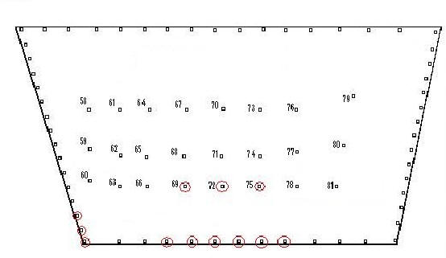
Diagram showing steel-column arrangement in WTC 7, view looking down on the roof. Circled columns were possibly damaged due to debris from WTC 1 collapse, some 350 feet away (NIST, 2005) so the damage was clearly non-symmetrical, and evidently, none of the core columns was severed by falling debris. WTC 7 was never hit by a plane.

A near-symmetrical collapse, as observed, evidently requires the simultaneous “pulling” of many of the support columns (see below, particularly discussion of Bazant & Zhou paper). The likelihood of complete and nearly-symmetrical collapse due to random fires as in the “official” theory is small, since non-symmetrical failure is so much more likely. If one or a few columns had failed, one might expect a portion of the building to crumble while leaving much of the building standing. For example, major portions of WTC 5 remained standing on 9/11 despite very significant impact damage and severe fires.

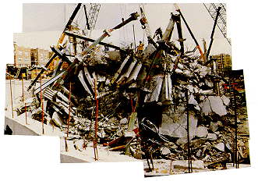
Non-symmetrical collapse of tall buildings when due to random causes. L'Ambiance Plaza collapse (right) shows how pancaked concrete floor slabs are largely intact and clearly reveal stacking effects with minimal fine dust, as expected from random progressive collapse. By contrast, concrete floors in the Twin Towers and WTC 7 were pulverized to dust -- as is common in controlled demolitions using explosives.
On the other hand, a major goal of controlled demolition using cutter-charges/explosives is the complete and straight-down-symmetrical collapse of buildings. The reader may wish to review controlled-demolition examples at http://www.implosionworld.com/cinema.htm for examples of complete symmetrical collapses due to carefully pre-positioned explosives. (The videos of the Philips Building, Southwark Towers, and Schuylkill Falls Tower collapses are particularly instructive.)

Concluding remarks in the FEMA report on the WTC 7 collapse lend support to these arguments:

The specifics of the fires in WTC 7 and how they caused the building to collapse [“official theory”] remain unknown at this time. Although the total diesel fuel on the premises contained massive potential energy, the best hypothesis [fire/debris-damage-caused collapse] has only a low probability of occurrence. Further research, investigation, and analyses are needed to resolve this issue. (FEMA, 2002, chapter 5; emphasis added.)

That is precisely the point: further investigation and analyses are indeed needed, including serious consideration of the controlled-demolition hypothesis which is neglected in all of the government reports (FEMA, NIST and 9-11 Commission reports). Note that the 9-11 Commission report does not even mention the collapse of WTC 7 on 9-11-01. (Commission, 2004) This is a striking omission of data highly relevant to the question of what really happened on 9-11.

4. No Previous Skyscraper Collapse Due to Fires

A New York Times article entitled “Engineers are baffled over the collapse of 7 WTC; Steel members have been partly evaporated,” provides relevant data.
Experts said no building like it [WTC7], a modern, steel-reinforced high-rise, had ever collapsed because of an uncontrolled fire. (Glanz, 2001; emphasis added.)
Fire engineering expert Norman Glover agrees:
Almost all large buildings will be the location for a major fire in their useful life. No major high-rise building has ever collapsed from fire…

The WTC [itself] was the location for such a fire in 1975; however, the building survived with minor damage and was repaired and returned to service.” (Glover, 2002)

That’s correct – no steel-beam high-rise had ever before (or since) completely collapsed due to fires! However, such complete and nearly symmetrical collapses in tall steel-frame buildings have occurred many times before -- all of them due to pre-positioned explosives in a procedure called “implosion” or controlled demolition. What a surprise, then, for such an occurrence in downtown Manhattan— three skyscrapers completely collapsed on the same day, September 11, 2001, presumably without the use of explosives.

Engineers have been trying to figure out exactly what happened and whether they should be worried about other buildings like it around the country… Most of the other buildings in the [area] stood despite suffering damage of all kinds, including fire... ‘Fire and the structural damage …would not explain steel members in the debris pile that appear to have been partly evaporated’, Dr. [Jonathan] Barnett said. (Glanz, 2001; emphasis added.)

The observed “partly evaporated” steel members is particularly upsetting to the official theory, since fires involving paper, office materials, even diesel fuel, cannot generate temperatures anywhere near the ~5,180ºF (~2860ºC) needed to evaporate steel. (Recall that WTC 7 was not hit by a jet, so there was no jet fuel involved in the fires in this building.) However, thermite-variants, RDX and other commonly-used incendiaries or explosives (i.e., cutter-charges) can readily slice through steel, thus cutting the support columns in a controlled demolition, and reach the required temperatures. This mystery needs to be explored – but is not mentioned in the “official” 9-11 Commission or NIST reports.

5. Squib-timing during the Collapse of WTC 7

Horizontal puffs of smoke and debris are observed emerging from WTC-7 on upper floors, in regular sequence, just as the building starts to collapse. (The reader may wish to view the close-up video clip again.) The upper floors have evidently not moved relative to one another yet, from what one can observe from the videos. In addition, the timing between the puffs is less than 0.2 seconds so air-expulsion due to collapsing floors (see Chertoff, 2005) is evidently excluded. Free-fall time for a floor to fall down to the next floor is significantly longer than 0.2 seconds: the equation for free fall, y = ½ gt², yields a little over 0.6 seconds, as this is near the initiation of the collapse.

However, the presence of such “squibs” proceeding up the side of the building is common when pre-positioned explosives are used, as can be observed at http://www.implosionworld.com/cinema.htm The same site shows that rapid timing between explosive squibs is also common. (It is instructive to view several of the implosion videos at this web site.) Thus, squibs as observed during the collapse of WTC 7 going up the side of the building in rapid sequence provide additional significant evidence for the use of pre-placed explosives. Release by the government (NIST, in particular) of all videographic and photographic data showing details of the fires, damage, and collapse of WTC 7 on 9/11/2001would allow us to analyze these squib data in greater detail, to determine whether breaking windows or explosive charges are evidenced in the observed puffs of smoke. Horizontal plumes and sounds of explosions are even more pronounced in available videos of the collapses of the WTC Towers (see sections 7 and 8 below).
Regarding this highly-secure building, a NY Times article entitled “Secretive C.I.A. Site in New York was Destroyed on Sept. 11,” provides an intriguing puzzle piece:

The C.I.A.'s undercover New York station was in the 47-story building at 7 World Trade Center… All of the agency's employees at the site were safely evacuated… The intelligence agency's employees were able to watch from their office windows while the twin towers burned just before they evacuated their own building. (Risen, 2001)

6. Early Drop of North Tower Antenna

The official FEMA 9-11 report admits a striking anomaly regarding the North Tower collapse:
Review of videotape recordings of the collapse taken from various angles indicates that the transmission tower on top of the structure began to move downward and laterally slightly before movement was evident at the exterior wall. This suggests that collapse began with one or more failures in the central core area of the building. (FEMA, 2002, chapter 2; emphasis added.)
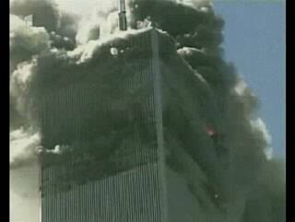
North Tower showing antenna (top) at beginning of collapse.
Yes, we can see for ourselves that the antenna drops first from videos of the North Tower collapse. (See http://911research.wtc7.net/wtc/evidence/videos/wtc1_close_frames.html; also http://home.comcast.net/~skydrifter/collapse.htm.) A NY Times article also notes this behavior:
The building stood for more than an hour and a half. Videos of the north tower's collapse appear to show that its television antenna began to drop a fraction of a second before the rest of the building. The observations suggest that the building's steel core somehow gave way first… (Glanz and Lipton, 2002; emphasis added)

But how? What caused the 47 enormous steel core columns of this building which supported the antenna to evidently give way nearly simultaneously, if not cutter charges?
The anomalous early antenna-drop was noted by the FEMA report (FEMA, 2002) and the New York Times (Glanz and Lipton, 2002) yet not resolved in the official reports (FEMA, 2002; Commission, 2004; NIST, 2005). The NIST report notes that:
...photographic and videographic records taken from due north of the WTC 1 collapse appeared to indicate that the antenna was sinking into the roof {McAllister 2002}.
When records from east and west vantage points were viewed, it was apparent that the building section above the impact area tilted to the south as the building collapsed. (NIST, 2005)
However, we find no quantitative analysis in the report which shows that this tilting of the building section was sufficient to account for the large apparent drop of the antenna as seen from the north, or that this building-section-tilting occurred before the apparent antenna drop. Furthermore, the FEMA investigators also reviewed "videotape recordings of the collapse taken from various angles" yet came to the sense that "collapse began with one or more failures in the central core area of the building." (FEMA, 2002) Quantitative analysis needs to be done and shown to resolve the issue.

7. Eyewitness Accounts of Flashes and Loud Explosions

Multiple loud explosions in rapid sequence were heard and reported by numerous observers in and near the WTC Towers, consistent with explosive demolition. Firemen and others described flashes and explosions in upper floors near where the plane entered, and in lower floors of WTC 2 just prior to its collapse, far below the region where the plane had struck the tower (Dwyer, 2005). For instance, at the start of the collapse of the South Tower a Fox News anchor reported:
There is an explosion at the base of the building… white smoke from the bottom… something happened at the base of the building! Then another explosion.” (De Grand Pre, 2002, emphasis added.)

Firefighter Edward Cachia independently reported:
[We] thought there was like an internal detonation, explosives, because it went in succession, boom, boom, boom, boom, and then the tower came down…It actually gave at a lower floor, not the floor where the plane hit. (Dwyer, 2005; emphasis added.)
And Assistant Fire Commissioner Stephen Gregory provides additional insights:
When I looked in the direction of the Trade Center before it came down, before No. 2 came down, ..I saw low-level flashes. In my conversation with Lieutenant Evangelista, never mentioning this to him, he questioned me and asked me if I saw low-level flashes in front of the building, and I agreed with him because I thought -- at that time I didn't know what it was. I mean, it could have been as a result of the building collapsing, things exploding, but I saw a flash flash flash and then it looked like the building came down.
Q. Was that on the lower level of the building or up where the fire was?
A. No, the lower level of the building. You know like when they demolish a building, how when they blow up a building, when it falls down? That's what I thought I saw. And I didn't broach the topic to him, but he asked me. He said I don't know if I'm crazy, but I just wanted to ask you because you were standing right next to me… He said did you see any flashes? I said, yes, well, I thought it was just me. He said no, I saw them, too... I mean, I equate it to the building coming down and pushing things around, it could have been electrical explosions, it could have been whatever." (Dwyer, 2005, Assistant Commissioner Stephen Gregory FDNY WCT2 File No. 91 10008; emphasis added.)

It is highly unlikely that jet fuel was present to generate such explosions especially on lower floors, and long after the planes hit the buildings. Dr. Shyam Sunder, Lead Investigator for NIST stated: "The jet fuel probably burned out in less than 10 minutes.” (Field, 2005) "Electrical explosions" would clearly be insufficient to bring a steel-frame skyscraper down, in any building built to code. On the other hand, pre-positioned explosives provide a plausible and simple explanation for the observed detonations followed by complete building collapses. Thus, it cannot be said that “no evidence” can be found for the use of explosives. This serious matter needs to be treated as a plausible scientific hypothesis and thoroughly investigated.

8. Ejection of Steel Beams and Debris-plumes from the Towers

The horizontal ejection of structural steel members for hundreds of feet and the pulverization of concrete to flour-like powder, observed clearly in the collapses of the WTC towers, provide further evidence for the use of explosives – as well-explained in http://911research.wtc7.net/talks/towers/index.html. (See also, Griffin, 2004, chapter 2.) The observed plumes or "squibs" are far below the pulverization region and therefore deserving of particular attention. They appear much like the plumes observed in http://www.implosionworld.com/cinema.htm (e.g., the controlled demolition of the Southwark Towers).
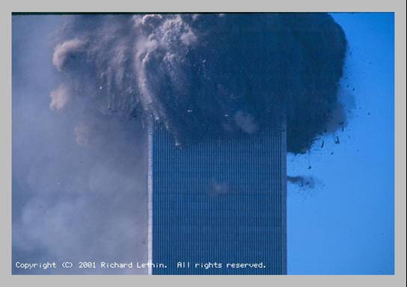
North Tower during top-down collapse.
Notice mysterious horizontal plumes far below pulverization region.
Unlike WTC7, the twin towers appear to have been exploded “top-down” rather than proceeding from the bottom – which is unusual for controlled demolition but clearly possible, depending on the order in which explosives are detonated. That is, explosives may have been placed on higher floors of the towers and exploded via radio signals so as to have early explosions near the region where the plane entered the tower. Certainly this hypothesis ought to be seriously considered in an independent investigation using all available data.

9. Rapid Collapses and Conservation of Momentum and Energy
The NIST team fairly admits that their report “does not actually include the structural behavior of the tower after the conditions for collapse initiation were reached.” (NIST, 2005, p. 80, fn. 1; emphasis added.) Quite a confession, since much of the external evidence for explosive demolition typically comes after collapse initiation, as seen in cases of acknowledged controlled demolition. (Harris, 2000.)
The rapid fall of the Towers and WTC7 has been analyzed by several engineers/scientists (http://911research.wtc7.net/wtc/analysis/proofs/speed.html; Griffin, 2004, chapter 2). The roof of WTC 7 (students and I are observing the southwest corner as it commences its steady fall) falls to earth in (6.5 +- 0.2) seconds, while an object dropped from the roof (in a vacuum) would hit the ground in 6.0 seconds. This follows from t = (2H/g)^{1/2}. Likewise, the Towers fall very rapidly to the ground, with the upper part falling nearly as rapidly as ejected debris which provide free-fall references (http://911research.wtc7.net/wtc/analysis/proofs/speed.html; Griffin, 2004, chapter 2). Where is the delay that must be expected due to conservation of momentum – one of the foundational Laws of Physics? That is, as upper-falling floors strike lower floors – and intact steel support columns – the fall must be significantly impeded by the impacted mass. If the central support columns remained standing, then the effective resistive mass would be less, but this is not the case – somehow the enormous support columns failed/disintegrated along with the falling floor pans. A recent (2006) analysis by Mechanical Engineering Professor Judy Wood on the rapid collapse of the Towers is instructive although preliminary: http://janedoe0911.tripod.com/BilliardBalls.html.

How do the upper floors fall so quickly, then, and still conserve momentum and energy in the collapsing buildings? The contradiction is ignored by FEMA, NIST and 9-11 Commission reports where conservation of energy and momentum and the fall-times were not analyzed. The paradox is easily resolved by the explosive demolition hypothesis, whereby explosives quickly remove lower-floor material including steel support columns and allow near free-fall-speed collapses (Harris, 2000).

And these explosives also readily account for the turning of the falling Towers to fine dust as the collapse ensues. Rather than a piling up with shattering of concrete as we might expect from non-explosive-caused progressive collapse (“official theory”), we find that most of the Towers material (concrete, carpet, steel, etc.) is converted to flour-like powder WHILE the buildings are falling. The Towers’ collapses are not typical random collapses, but quite possibly a series of “shock-and-awe” explosions coupled with the use of thermate-incendiaries – at least the evidence points strongly in this direction. The hypothesis ought to be explored further.

Those who wish to preserve fundamental physical laws as inviolate may wish to take a closer look. Consider the collapse of the South WTC Tower on 9-11: http://www.911research.com/wtc/evidence/videos/docs/south_tower_collapse.mpeg

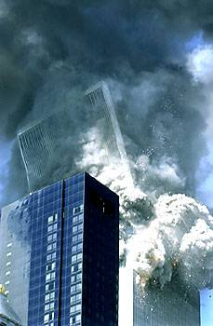
Top ~ 30 floors of South Tower topple over.
What happens to the block and its angular momentum?

We observe that approximately 30 upper floors begin to rotate as a block, to the south and east. They begin to topple over, not fall straight down. The torque due to gravity on this block is enormous, as is its angular momentum. But then – and this I’m still puzzling over – this block turned mostly to powder in mid-air! How can we understand this strange behavior, without explosives? Remarkable, amazing – and demanding scrutiny since the US government-funded reports failed to analyze this phenomenon. But, of course, the Final NIST 9-11 report “does not actually include the structural behavior of the tower after the conditions for collapse initiation were reached.” (NIST, 2005, p. 80, fn. 1; emphasis added.)

Indeed, if we seek the truth of the matter, we must NOT ignore the data to be observed during the actual collapses of the towers, as the NIST team admits they did. But why did they follow such a non-scientific procedure as to ignore highly-relevant data? The business smacks of political constraints on what was supposed to be an “open and thorough” investigation. (See Mooney, 2005.)

So I with others call for an open and thorough investigation. I hope the international community will rise to the challenge. The field is wide open for considering the alternative hypothesis outlined here, due to its neglect in studies funded by the US government.

10. Controlled Demolition “Implosions” Require Skill

The occurrence of nearly symmetrical, straight-down and complete collapses of the WTC 7 and the Towers is particularly upsetting to the “official” theory that random fires plus damage caused all these collapses. Even with high-level cutting charges, achieving such results requires a great deal of pre-planning and expertise. As Tom Harris, an authority in this field, has explained:

The main challenge in bringing a building down is controlling which way it falls. Ideally, a blasting crew will be able to tumble the building over on one side, into a parking lot or other open area. This sort of blast is the easiest to execute. Tipping a building over is something like felling a tree. To topple the building to the north, the blasters detonate explosives on the north side of the building first…

Sometimes, though, a building is surrounded by structures that must be preserved. In this case, the blasters proceed with a true implosion, demolishing the building so that it collapses straight down into its own footprint (the total area at the base of the building). This feat requires such skill that only a handful of demolition companies in the world will attempt it.
Blasters approach each project a little differently... [A good] option is to detonate the columns at the center of the building before the other columns so that the building's sides fall inward.... Generally speaking, blasters will explode the major support columns on the lower floors first and then a few upper stories… [nb: The upper floors then fall as a tamper, resulting in “progressive collapse”-- this is common in controlled demolition.] (Harris, 2000; emphasis added.)

Careful observation of the collapse of WTC 7 (video clips above) demonstrates a downward “kink” near the center of the building first, suggesting “pulling” of the support columns, then the building’s sides pull inward such that the building “collapses straight down into its own footprint” (Harris, 2000). The plumes of debris observed on upper floors of WTC 7 as the collapse begins appear consistent with explosive cutting of supports for "a few upper stories" as outlined above. FEMA admitted that WTC 7 collapsed onto a well-confined footprint:
The collapse of WTC 7 had a small debris field as the facade was pulled downward, suggesting an internal failure and implosion… The average debris field radius was approximately 70 feet. (FEMA, 2002, chapter 5.)
Evidently we agree that this was a beautifully done implosion in the collapse of WTC 7, and yet:
This feat requires such skill that only a handful of demolition companies in the world will attempt it. (Harris, 2000; emphasis added.)
Consider: Why would terrorists undertake straight-down collapses of WTC7 and the Towers, when “toppling-over” falls would require much less work and would do much more damage in downtown Manhattan? And where would they obtain the necessary skills and access to the buildings for a symmetrical implosion anyway? These questions suggest the need for further investigation.
One of the people a thorough investigation should question would be demolition expert Mark Loizeaux, president of Controlled Demolition, Inc. Speaking of the way the WTC buildings came down, he said in an interview: “If I were to bring the towers down, I would put explosives in the basement to get the weight of the building to help collapse the structure.” (Bollyn, 2002; emphasis added.)

Just right – “explosives in the basement” agrees with eyewitness reports of pre-collapse explosions down low in the buildings (point 7 above). Also, this would be the way to effectively sever the support columns, consistent with both the apparent initial drop of the communication tower (WTC Tower 1) and the “kink” in the middle of WTC 7 as its collapse began. Yes, and as president of Controlled Demolition, Inc., Mr. Loizeaux would know the “handful of demolition companies in the world [that] will attempt” a symmetrical controlled demolition or "implosion". (Harris, 2000) His company is certainly one of these and was hired to do the rapid clean-up work following the building collapses.

If you still haven’t looked at the rapid symmetrical collapse of WTC7 for yourself, why not do so now? Watch for the initial “kink” or drop in the middle, and for the “squibs” blowing in sequence up the side of the building, and notice the symmetrical, straight-down collapse. All of these features are common in controlled demolitions. . See for yourself at: http://911research.wtc7.net/talks/wtc/videos.html . A great deal of further information is presented from a serious scientific point-of-view at this site http://wtc7.net/ .

11. Steel Column Temperatures of 800°C Needed: A Problem in the Argument of Bazant and Zhou

A Mechanical Engineering professor suggested that I review a paper by Zedenek P. Bazant and Yong Zhou, which I did. Quoting:
The 110-story towers of the World Trade Center were designed to withstand as a whole the forces caused by a horizontal impact of a large commercial aircraft. So why did a total collapse occur? (Bazant and Zhou, 2002, p. 2.)

Correct – the WTC Towers were designed to withstand forces caused by large commercial aircraft – we can agree on that. MIT’s Thomas Eagar also concurs “because the number of columns lost on the initial impact was not large and the loads were shifted to remaining columns in this highly redundant structure” (Eagar and Musso, 2001).

We continue with Bazant & Zhou:
The conflagration, caused by the aircraft fuel spilled into the structure, causes the steel of the columns to be exposed to sustained temperatures apparently exceeding 800ºC… (Bazant and Zhou, 2002, p. 2.)

But here we note from the recent NIST report that: “The initial jet fuel fires themselves lasted at most a few minutes” and office material fires would burn out within about 20 minutes in a given location. (NIST, 2005; p. 179, emphasis added.) Certainly jet fuel burning was not enough to raise steel to sustained temperatures above 800ºC. But we continue:

Once more than half of the columns in the critical floor.. suffer buckling (stage 3), the weight of the upper part of the structure above this floor can no longer be supported, and so the upper part starts falling down onto the lower part below…”(Bazant and Zhou, 2002, p. 2.)

Bazant & Zhou do not explain how “more than half of the columns in the critical floor [can] suffer buckling” at the same time to precipitate the complete and nearly symmetrical collapse observed. There were 47 huge steel core columns in each Tower, and 24 such support columns in WTC 7 (NIST 2005; NISTb, 2005).
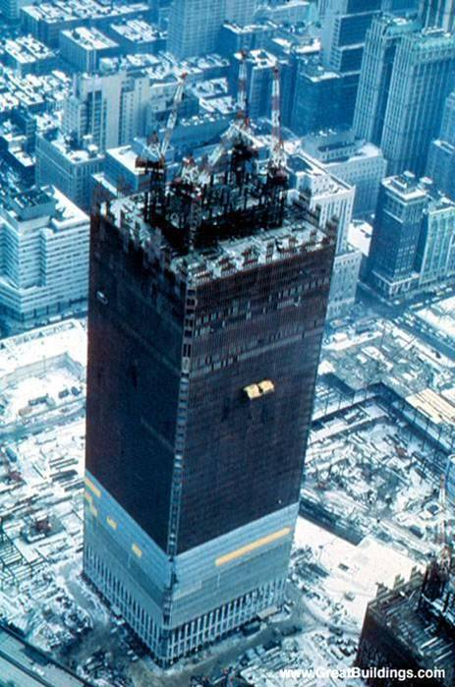
The WTC towers were solidly constructed with 47 steel core
columns and 240 perimeter steel columns. 287 steel-columns total.
Many doubt that random fires/damage could cause them to
collapse straight down (official theory), and suspect explosives.

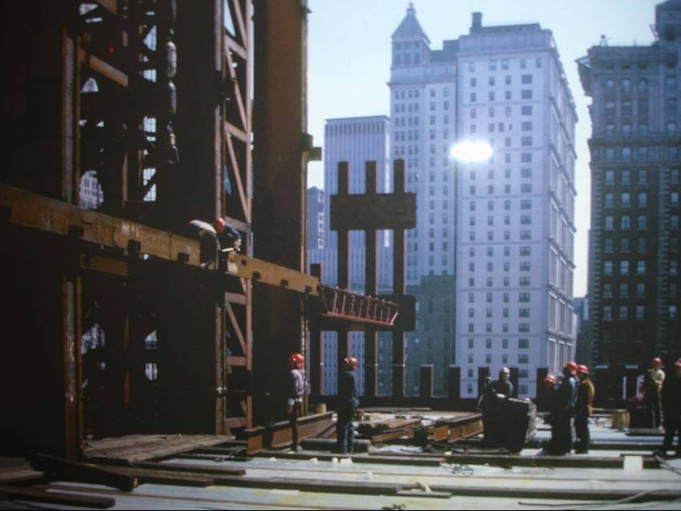
Steel-frame: Huge core (left) is an enormous heat sink. Notice workers standing on floor pan which is firmly attached to the interconnected core columns.

They do NOT explain how steel-column temperatures above 800ºC were achieved near-simultaneously due to burning office materials. NIST notes that office materials in an area burn for about 15-20 minutes, then are consumed away (NIST, 2005, pp. 117, 179). This is evidently not long enough to raise steel column temperatures above 800ºC as required in the Bazant & Zhou model, given the enormous heat sinks of the structures. And to have three buildings completely collapse due to this unlikely mechanism on the same day strains credulity. Moreover, the Final NIST report on the Towers admits:
Of the more than 170 areas examined on 16 perimeter column panels, only three columns had evidence that the steel reached temperatures above 250ºC… Only two core column specimens had sufficient paint remaining to make such an analysis, and their temperatures did not reach 250 ºC. ... Using metallographic analysis, NIST determined that there was no evidence that any of the samples had reached temperatures above 600 ºC. (NIST, 2005, pp. 176-177; emphasis added.)

Relevant to this point, Eagar noted that "Factors such as flame volume and quantity of soot decrease the radiative heat loss in the fire, moving the temperature closer to the maximum of 1,000 ºC." (Eagar and Musso, 2001) While this is the maximum air temperature possible in the WTC fires, this does not mean that the structural steel reached this temperature in the time the fires acted. Indeed, NIST emphasizes that there was no evidence that "any of the samples had reached temperatures above 600 ºC." This statement is consistent with their data plots of "predicted column temperatures", which "shows maximum temperature reached by each column" in that no temperature above 600 ºC is given for any of the steel columns. (NIST, 2005.)
As for WTC 7, Bazant & Zhou say little but mention in a separate “addendum” that burning natural gas might have been a source of the needed heat (Bazant and Zhou, March 2002, p. 370). The FEMA report (FEMA, 2002) addresses this issue:

Early news reports had indicated that a high pressure, 24-inch gas main was located in the vicinity of the building [WTC 7]; however, this proved not to be true." (FEMA, 2002, chapter 5; emphasis added.)

12. Problems in the NIST Report: Inadequate Steel Temperatures and Tweaked Models

I have read through the hundreds of pages of the Final NIST report on the collapses of the WTC Towers. (NIST, 2005) It is interesting to note that NIST “decoupled” and delayed their final report on WTC 7, which is overdue as of this writing (NIST, 2005; NISTb, 2005). I agree with some of the NIST report; for example:
Both WTC 1 and WTC 2 were stable after the aircraft impact, standing for 102 min and 56 min, respectively. The global analyses with structural impact damage showed that both towers had considerable reserve capacity. This was confirmed by analysis of the post-impact vibration of WTC 2… where the damaged tower oscillated at a period nearly equal to the first mode period calculated for the undamaged structure. (NIST, 2005, p. 144; emphasis added.)
At any given location, the duration of [air, not steel] temperatures near 1,000ºC was about 15 min to 20 min. The rest of the time, the calculated temperatures were near 500ºC or below.” (NIST, 2005, p. 127, emphasis added.)
NIST contracted with Underwriters Laboratories, Inc. to conduct tests to obtain information on the fire endurance of trusses like those in the WTC towers… All four test specimens sustained the maximum design load for approximately 2 hours without collapsing.” (NIST, 2005, p. 140, emphasis added.)

However, I along with others challenge NIST’s collapse theory. NIST maintains that all three building collapses were fire-initiated despite the observations above, particularly the fact that fire endurance tests with actual models did not result in collapse. In a paper by fire-engineering experts in the UK, we find:
The basis of NIST’s collapse theory is… column behaviour in fire... However, we believe that a considerable difference in downward displace between the [47] core and [240] perimeter columns, much greater than the 300 mm proposed, is required for the collapse theory to hold true… [Our] lower reliance on passive fire protection is in contrast to the NIST work where the amount of fire protection on the truss elements is believed to be a significant factor in defining the time to collapse… The [proposed effect] is swamped by thermal expansion … Thermal expansion and the response of the whole frame to this effect has NOT been described as yet [by NIST]. (Lane and Lamont, 2005.)

I agree with these pointed objections, particularly that the “response of the whole frame” of each building should be considered, especially heat transport to the whole frame from localized fires, and that the “core columns cannot pull the exterior columns in via the floor.” (Lane and Lamont, 2005)
The computerized models of the Towers in the NIST study, which incorporate many features of the buildings and the fires on 9-11-01, are less than convincing. The Final report states:
The Investigation Team then defined three cases for each building by combining the middle, less severe, and more severe values of the influential variables. Upon a preliminary examination of the middle cases, it became clear that the towers would likely remain standing. The less severe cases were discarded after the aircraft impact results were compared to observed events. The middle cases (which became Case A for WTC 1 and Case C for WTC 2) were discarded after the structural response analysis of major subsystems were compared to observed events. (NIST, 2005, p. 142; emphasis added.)
The NIST report makes for interesting reading. The less severe cases based on empirical data were discarded because they did not result in building collapse. But ‘one must save the hypothesis,’ so more severe cases were tried and the simulations tweaked, as we read in the NIST report:
The more severe case (which became Case B for WTC 1 and Case D for WTC 2) was used for the global analysis of each tower. Complete sets of simulations were then performed for Cases B and D. To the extent that the simulations deviated from the photographic evidence or eyewitness reports [e.g., complete collapse occurred], the investigators adjusted the input, but only within the range of physical reality. Thus, for instance,…the pulling forces on the perimeter columns by the sagging floors were adjusted... (NIST, 2005, p. 142; emphasis added.)
The primary role of the floors in the collapse of the towers was to provide inward pull forces that induced inward bowing of perimeter columns. (NIST, 2005, p. 180; emphasis added.)
How fun (perhaps) to tweak the model like that, until the building collapses -- until one gets the desired result. But the end result of such tweaked computer hypotheticals is not compelling. Notice that the “the pulling forces on the perimeter columns by the sagging floors were adjusted” (NIST, 2005, p. 142; emphasis added) to get the perimeter columns to yield sufficiently – one suspects these were “adjusted” by hand quite a bit -- even though the UK experts complained that “the core columns cannot pull the exterior [i.e., perimeter] columns in via the floor.” (Lane and Lamont, 2005; emphasis added.)

I also agree with Kevin Ryan’s objections regarding the NIST study. Kevin Ryan, at the time a manager at Underwriters Laboratories (UL), makes a point of the non-collapse of actual WTC-based models in his letter to Frank Gayle of NIST:

As I'm sure you know, the company I work for certified the steel components used in the construction of the WTC buildings. In requesting information from both our CEO and Fire Protection business manager last year… they suggested we all be patient and understand that UL was working with your team… I'm aware of UL's attempts to help, including performing tests on models of the floor assemblies. But the results of these tests… indicate that the buildings should have easily withstood the thermal stress caused by… burning [jet fuel, paper, etc.]. (Ryan, 2004)

That models of WTC trusses at Underwriter Laboratories (UL) subjected to fires did NOT fail is also admitted in the final NIST report:
NIST contracted with Underwriters Laboratories, Inc. to conduct tests to obtain information on the fire endurance of trusses like those in the WTC towers…. All four test specimens sustained the maximum design load for approximately 2 hours without collapsing… The Investigation Team was cautious about using these results directly in the formulation of collapse hypotheses. In addition to the scaling issues raised by the test results, the fires in the towers on September 11, and the resulting exposure of the floor systems, were substantially different from the conditions in the test furnaces. Nonetheless, the [empirical test] results established that this type of assembly was capable of sustaining a large gravity load, without collapsing, for a substantial period of time relative to the duration of the fires in any given location on September 11. (NIST, 2005, p. 141; emphasis added.)

So how does the NIST team justify the WTC collapses, when actual models fail to collapse and there are zero examples of fire-caused high-rise collapses? Easy, NIST concocted computer-generated hypotheticals for very “severe” cases, called cases B and D (NIST, 2005, pp. 124-138). Of course, the details are rather hidden to us. And they omit consideration of the complete, rapid and symmetrical nature of the collapses.

Indeed, NIST makes the startling admission in a footnote on page 80 of their Final Report:
The focus of the Investigation was on the sequence of events from the instant of aircraft impact to the initiation of collapse for each tower. For brevity in this report, this sequence is referred to as the "probable collapse sequence," although it does not actually include the structural behavior of the tower after the conditions for collapse initiation were reached...(NIST, 2005, p. 80, fn. 12; emphasis added.)
Again, on page 142, NIST admits that their computer simulation only proceeds until the building is “poised for collapse”, thus ignoring any data from that time on.
The results were a simulation of the structural deterioration of each tower from the time of aircraft impact to the time at which the building became unstable, i.e., was poised for collapse. ...(NIST, 2005, p. 142; emphasis added.)

What about the subsequent complete, rapid and symmetrical collapse of the buildings? What about the observed squibs? What about the antenna dropping first in the North Tower? What about the molten metal observed in the basement areas in large pools in both Towers and WTC 7 as well? Never mind all that: NIST did not discuss at all any data after the buildings were “poised for collapse.” Well, some of us want to look at ALL the data, without "black-box" computer simulations that are “adjusted,” perhaps to make them fit the desired outcome. An hypothesis which is non-refutable is non-scientific. On the other hand, Occam's razor suggests that the simplest explanation which addresses and satisfies ALL the evidence is most probably correct.

13. NIST's Failure to Show Visualizations

An article in the journal New Civil Engineering (NCE) lends support to concerns about the NIST analysis of the WTC collapses. It states:
World Trade Center disaster investigators [at NIST] are refusing to show computer visualizations of the collapse of the Twin Towers despite calls from leading structural and fire engineers, NCE has learned. Visualisations of collapse mechanisms are routinely used to validate the type of finite element analysis model used by the [NIST] investigators. The collapse mechanism and the role played by the hat truss at the top of the tower has been the focus of debate since the US National Institute of Standards & Technology (NIST) published its findings….
University of Manchester [U.K.] professor of structural engineering Colin Bailey said there was a lot to be gained from visualising the structural response. “NIST should really show the visualisations; otherwise the opportunity to correlate them back to the video evidence and identify any errors in the modeling will be lost,” he said….
A leading US structural engineer said NIST had obviously devoted enormous resources to the development of the impact and fire models. “By comparison the global structural model is not as sophisticated,” he said. “The software used [by NIST] has been pushed to new limits, and there have been a lot of simplifications, extrapolations and judgment calls.” (Parker, 2005; emphasis added.)

Here we have serious concerns about the NIST WTC collapse report raised by structural and fire engineers, augmenting the arguments raised here by a physicist.

The thirteen points above provide scientific data and analyses that support my call for an immediate investigation of 9/11 events, while challenging the official story. A few other considerations provide further motivation for the proposed urgent investigation.

Some Additional Considerations

“Burning Questions that Need Answers”

I agree with this urgent yet reasoned assessment of expert fire-protection engineers, as boldly editorialized in the journal Fire Engineering:

Respected members of the fire protection engineering community are beginning to raise red flags, and a resonating theory has emerged:
The structural damage from the planes and the explosive ignition of jet fuel in themselves were not enough to bring down the towers....
Fire Engineering has good reason to believe that the "official investigation" blessed by FEMA and run by the American Society of Civil Engineers is a half-baked farce that may already have been commandeered by political forces whose primary interests, to put it mildly, lie far afield of full disclosure. Except for the marginal benefit obtained from a three-day, visual walk-through of evidence sites conducted by ASCE investigation committee members- described by one close source as a "tourist trip"-no one's checking the evidence for anything.
Some citizens are taking to the streets to protest the investigation sellout. Sally Regenhard, for one, wants to know why and how the building fell as it did upon her unfortunate son Christian, an FDNY probationary firefighter. And so do we.
Clearly, there are burning questions that need answers. Based on the incident's magnitude alone, a full-throttle, fully resourced, forensic investigation is imperative. More important, from a moral standpoint, [are considerations] for the safety of present and future generations… (Manning, 2002; emphasis added).

This editorial does not mention the controlled-demolition hypothesis, but rightfully objects to the rapid destruction of the structural steel which would provide crucial evidence from the crime scene. We agree that such destruction of evidence is wrong, and that a thorough investigation is imperative.

For more than three months, structural steel from the World Trade Center has been and continues to be cut up and sold for scrap. Crucial evidence that could answer many questions about high-rise building design practices and performance under fire conditions is on the slow boat to China, perhaps never to be seen again in America until you buy your next car.
Such destruction of evidence shows the astounding ignorance of government officials to the value of a thorough, scientific investigation of the largest fire-induced collapse in world history. I have combed through our national standard for fire investigation, NFPA 921, but nowhere in it does one find an exemption allowing the destruction of evidence for buildings over 10 stories tall. (Manning, 2002; emphasis added).

In an editorial in Fire Engineering, September, 2004, Bill Manning criticizes the 9/11 Commission report and renews his call for a new investigation, the major goal of this paper also:
The recommendations contained within Chapter 9 of the 9/11 Commission Report, the chapter dealing with emergency response, are disappointingly sparse in details. Surely, the largest and most tragic emergency response in history demands a more intensive, more critical investigative effort, especially since the 9/11 Commission touts its effort as the "definitive account" of the incident. More importantly, the response community, the public, and the fallen heroes and their families deserve the naked truth, whatever that may be.
To obscure the truth for political motivation is contemptible in itself. To use our fallen brothers to accomplish that political sleight-of-hand is nothing short of monstrous.
The 9/11 Commission's treatment of the emergency response component is a disgrace. The fire service and the public must demand that a new investigative body be assembled to launch a full, complete, and politically impartial investigation into the emergency response issues leading up to and including the 9/11 disaster. Or don't we have the stomach for it? To do anything less would be a disservice to the 343 brothers and all the other good people who perished that day, a disservice to our nation, and a disservice to ourselves. (Manning, 2004)

Analysis by Whistleblower Ryan

Kevin Ryan, the whistleblower from Underwriters Laboratories, did his own brief statistical analysis in a recent letter regarding the NIST report, arguing that probabilities of collapse-initiation needed to be calculated (Ryan, 2005). NIST nowhere provides such a likelihood analysis for their non-explosive collapse model. Ryan’s estimate is that the probability that fires and damage (the “official theory”) could cause the Towers complete collapse is less than one in a trillion, and the probability is much less still when the complete collapse of WTC7 is included:
To follow the latest "leading hypothesis" [of NIST], what are the odds that all the fireproofing fell off in just the right places, even far from the point of impact? Without much test data, let's say it's one in a thousand. And what are the odds that the office furnishings converged to supply highly directed and (somehow) forced-oxygen fires at very precise points on the remaining columns? Is it another one in a thousand? What is the chance that those points would then all soften in unison, and give way perfectly, so that the highly dubious "progressive global collapse" theory could be born? I wouldn't even care to guess. But finally, with well over a hundred fires in tall buildings through history, what are the chances that the first, second and third incidents of fire-induced collapse would all occur on the same day? Let's say it's one in a million. Considering just these few points we're looking at a one in a trillion chance, using generous estimates and not really considering the third building (no plane, no jet fuel, different construction [for WTC 7]).
How convenient that our miraculous result, combined with several other trains of similarly unlikely events [no interception of hijacked planes by the military on 9/11, etc.], gives us reason to invade the few most strategically important lands for the production of oil and natural gas…” (Ryan, 2005).
Nor does NIST (or FEMA or the 9-11 Commission) even mention the molten metals found in the basements of all three buildings (WTC 1, 2 and 7).

So where does that leave us? I strongly agree with Kevin Ryan when he says,
This [“official”] story just does not add up…. That fact should be of great concern to all Americans…. There is no question that the events of 9/11 are the emotional driving force behind the War on Terror. And the issue of the WTC collapse is at the crux of the story of 9/11. (Ryan, 2004; emphasis added.)
Faculty Support Investigation

I presented my objections to the “official” theory at a seminar at BYU on September 22, 2005, to about sixty people. I also showed evidence and scientific arguments for the controlled demolition theory. In attendance were faculty from Physics, Mechanical Engineering, Civil Engineering, Electrical Engineering, Psychology, Geology, and Mathematics – and perhaps other departments as I did not recognize all of the people present. A local university and college were represented (BYU and Utah Valley State College).

The discussion was vigorous and lasted nearly two hours. It ended only when a university class needed the room. After presenting the material summarized here, including actually looking at and discussing the collapses of WTC 7 and the Towers, only one attendee disagreed (by hand-vote) that further investigation of the WTC collapses was called for. The next day, the dissenting professor said he had further thought about it and now agreed that more investigation was needed. He joined the others in hoping that the 6,899 photographs and 6,977 segments of video footage held by NIST plus others held by the FBI would be released for independent scrutiny; photos largely from private photographers (NIST, 2005, p. 81). Therefore, I along with others call for the release of these data to a cross-disciplinary, preferably international team of scientists and engineers.

Inconsistencies in “Official” Models

Finally, and by way of review, we consider the variations and inconsistencies in the fire/damaged-caused collapse models with time. The earliest model, promoted by various media sources, was that the fires in the towers were sufficiently hot to actually melt the steel in the buildings, thus causing their collapse. For example, Chris Wise in a BBC piece spouted out false notions with great gusto
“It was the fire that killed the buildings. There’s nothing on earth that could survive those temperatures with that amount of fuel burning… The columns would have melted, the floors would have melted and eventually they would have collapsed one on top of the other.” (quoted in Paul and Hoffman, 2004, p. 25)
But as we have seen from later serious studies, most of the jet fuel burned out within minutes following impact. And recall the statement of expert Dr. Gayle refuting the notion that fires in the WTC buildings were sufficiently hot to melt the steel supports:
Your gut reaction would be the jet fuel is what made the fire so very intense, a lot of people figured that's what melted the steel. Indeed it did not, the steel did not melt. (Field, 2005; emphasis added)

Then we have the model of Bazant and Zhou, which requires the majority of the 47 huge steel columns on a floor of each Tower to reach sustained temperatures of 800ºC and buckle (not melt) – at the same time. But as we’ve seen, such temperatures are very difficult to reach while burning office materials, in these connected steel structures where the heat is wicked away by heat transport. (Paul and Hoffman, 2004, p. 26) And then to undergo failure at the same time for straight down collapse, well, no, this scenario is far too improbable.
That approach was, understandably, abandoned in the next effort, that by FEMA (FEMA, 2002). The FEMA team largely adopted the theory of Dr. Thomas Eagar (Eagar and Musso, 2001), which was also presented in the NOVA presentation “Why the Towers Fell” (NOVA, 2002). Eagar expresses the view that "the failure of the steel was due to two factors: loss of strength due to the temperature of the fire, and loss of structural integrity due to distortion of the steel from the non-uniform temperatures in the fire." (Eagar and Musso, 2001) Instead of having the columns fail simultaneously, FEMA has floor pans in the Towers warp due to fires, and the floor connections to the vertical beams break, and these floor pans then fall down onto the floor pans below, initiating “progressive collapse” or pancaking of one floor pan on another. Very simple. But not so fast – what happens to the enormous core columns to which the floors were firmly attached? Why don’t these remain standing like a spindle with the floor pans falling down around them, since the connections are presumed to have broken away? This interconnected steel core is founded on bedrock (Manhattan schist). FEMA does not totally ignore the core:
As the floors collapsed, this left tall freestanding portions of the exterior wall and possibly central core columns. As the unsupported height of these freestanding exterior wall elements increased [no mention of the huge central core anymore!], they buckled at the bolted column splice connections and also collapsed.” (FEMA. 2002; emphasis added)
This approach finally fails to account for the observed collapse of the 47 interconnected core columns which are massive and designed to bear the weight of the buildings, and it has the striking weakness of evidently requiring the connections of the floor pans to the vertical columns to break, both at the core and at the perimeter columns, more or less simultaneously.
That didn’t work out, so NIST goes back to the drawing board. They require that the connections of the floor pans to vertical columns do NOT fail (contrary to FEMA’s model), but rather that the floor pans “pull” with enormous force, sufficient to cause the perimeter columns to significantly pull in, leading to final failure (contrary to objections of ARUP Fire experts, discussed above). Also, NIST constructs a computer model -- but realistic cases do not actually lead to building collapse. So they “adjust” inputs until the model finally shows collapse initiation for the most severe cases. The details of these “adjustments” are hidden from us, in their computerized hypotheticals, but “the hypothesis is saved.” NIST also has Underwriters Laboratories construct models of the WTC trusses, but the models withstand all fires in tests and do NOT collapse. (See above for details.)
We are left without a compelling fire/impact-damage model, unless one blindly accepts the NIST computer simulation while ignoring the model fire-tests, which I’m not willing to do. NIST did not even do the routinely-used visualizations to validate their finite-element analysis model (point 14 above). And none of the “official” models outlined above accounts for what happens to the buildings AFTER the building is “poised for collapse” (NIST, 2005, p. 142) – namely the rapid and nearly-symmetrical and complete collapses. Reports of explosions, heard and seen, are not discussed. And they ignore the squibs seen ejected from floors far from where the jets hit – particularly seen in WTC 7 (where no jet hit at all). Finally, what about that molten metal under the rubble piles of all three WTC skyscrapers and the yellow-white hot molten metal seen flowing from the South Tower just prior to its collapse?
Remarkably, the controlled demolition hypothesis accounts for all the available data rather easily. The core columns on lower floors are cut using explosives/incendiaries, near-simultaneously, along with cutting charges detonated up higher so that gravity acting on now-unsupported floors helps bring down the buildings quickly. The collapses are thus near-symmetrical, rapid and complete, with accompanying squibs -- really very standard stuff for demolition experts. Thermate (whose end product is molten iron) used on some of the steel columns readily accounts for the molten metal which then pooled beneath the rubble piles as well as the sulfidation observed in steel from both the WTC 7 and Towers rubble piles (points 1 and 2 above).
I believe this is a straightforward hypothesis, much more probable actually than the official hypothesis. It deserves scientific scrutiny, beyond that which I have been able to outline in this treatise.

Conclusions

I have called attention to glaring inadequacies in the “final” reports funded by the US government. I have also presented multiple evidences for an alternative hypothesis. In particular, the official theory lacks repeatability in that no actual models or buildings (before or since 9-11-01) have been observed to completely collapse due to the proposed fire-based mechanisms. On the other hand, dozens of buildings have been completely and symmetrically demolished through the use of pre-positioned explosives. And high-temperature chemical reactions can account for the observed large pools of molten metal, under both Towers and WTC 7, and the sulfidation of structural steel. The controlled-demolition hypothesis cannot be dismissed as "junk science" because it better satisfies tests of repeatability and parsimony. It ought to be seriously (scientifically) investigated and debated.
A truly independent, cross-disciplinary, international panel should be formed. Such a panel would consider all viable hypotheses, including the pre-positioned-explosives theory, guided not by politicized notions and constraints, but rather by observations and calculations, to reach a scientific conclusion. If possible it would question, under oath, the officials who approved the rapid removal and destruction of the WTC steel beams and columns before they could be properly analyzed.
None of the government-funded studies have provided serious analyses of the explosive demolition hypothesis at all. Until the above steps are taken, the case for accusing ill-trained Muslims of causing all the destruction on 9-11-01 is far from compelling. It just does not add up.
And that fact should be of great concern to Americans. (Ryan, 2004). Clearly, we must find out what really caused the WTC skyscrapers to collapse as they did. The implications of what happened on 9/11/2001 clearly supercede partisan politics. Physics sheds light on the issue which we ignore to our peril as we contemplate the wars that have been and may yet be justified on the basis of the 9/11 tragedy and its "official" interpretation.
To this end, NIST must release the 6,899 photographs and over 300 hours of video recordings – acquired mostly by private parties – which it admits to holding (NIST, 2005, p. 81). Evidence relating to WTC 7 and its mysterious collapse must not be held back. In particular, photos and analyses of the molten metal observed in the basements of both Towers and WTC7 need to be brought forth to the international community of scientists and engineers immediately. Therefore, along with others, I call for the release of these and all relevant data for scrutiny by a cross-disciplinary, international team of researchers. The explosive-demolition hypothesis will be considered: all options will be on the table.

AFTERWORD

In writing this paper, I call for a serious investigation of the hypothesis that WTC7 and the Twin Towers were brought down, not just by impact damage and fires, but through the carefully planned use of explosives/incendiaries. I have presented ample evidence for the controlled-demolition hypothesis, which is testable and falsifiable and yet has not been seriously considered in any of the studies funded by the US government.
At the same time, I acknowledge that other notions have sprung up in the near vacuum of official consideration of this very plausible hypothesis. These notions must be subjected to careful scrutiny. I by no means endorse all such ideas. A March 2005 article in Popular Mechanics focuses on poorly-supported claims and proceeds to ridicule the whole “9-11 truth movement” (Chertoff, 2005). Serious replies to this article have already been written (Hoffman, 2005; Baker, 2005; Meyer, 2005).
William Rodriguez has sent important information (private communications, November 2005) which I append in closing:

"Thank you so much for coming out with a report questioning the "official Story" of 9/11. I read with a lot of dedication your paper and I distributed it widely to all the Victims and survivors of that day (I am the leader of the families and the last person pulled from the rubble from the North Tower).
You are just missing my experience. I told the 9/11 Commission about the explosions and the events on the sub-basement on that day. They did not put it in the final report. Please check the internet under "William Rodriguez 9/11". I am trying to raise the same questions. Since I am a respected figure internationally, I noticed how my testimony has been presented unedited all over the world. But in the USA, I am edited and even though I have a lot of respect from the media, I am asked constantly about other subjects and issues but nothing about the explosions of that day. Congratulations from the side of the really affected on that day. Keep up your investigations.
William Rodriguez Hispanic Victims Group, 9/11 United Services Group, Lower Manhattan Family Advisory Counsel

I thanked Mr. Rodriguez and asked him how he could say the explosion came from the sub-basement below him, rather than far above (where the plane hit), also regarding the timing of the explosions. He replied:
About my experience. My basis was, like I told the Commission, there was an explosion that came from under our feet, we were pushed upwards lightly by the effect, I was on basement level 1 and it sounded that it came from B2 and B3 level. Rapidly after that we heard the impact far away at the top. My assertions are [that] my 20 years experience there and witnessing prior to that many other noises [enable me] to conclude without any doubt where the sounds were coming from. 2ND- Some of the same people that I saved gave testimonies in interviews of the same experience prior to my actually being reunited with them after the event!!! Like I explained, some of these survivors stories were told in countless [interviews] of coverage, but in SPANISH!! I have the actual recordings available of some of the Television Specials that featured our stories.

Mr. Rodriguez worked for years in the building and his perception of sounds cannot be overlooked. He is a reliable witness. Above (and elsewhere) he records that the explosion in the sub-basement was followed “rapidly after that” by the sound of an impact far above. This assertion is remarkable for it strongly suggests that the colliding plane or its fuel could not have caused the (earlier) explosion in the sub-basement. William Rodriguez and other witnesses may shed additional light on the explosions in the Towers on 9/11/2001.

ACKNOWLEDGMENTS

I gratefully acknowledge comments and contributions by Jim Hoffman, Alex Floum, Jeffrey Farrer, Carl Weis, Victoria Ashley, William Rodriguez and Jeff Strahl, the scholarly teams at http://www.911truth.org/ and http://www.st911.org/, and Professors Jack Weyland, David Ray Griffin, James Fetzer, Bryan Peterson, Paul Zarembka and Derrick Grimmer.

REFERENCES

Baker, Jeremy (2005). “Contrary to Popular (Mechanics’) Belief,” Global Outlook, Issue 10, p. 14 (Spring-Summer 2005).
Barnett, J. R., Biederman, R.R. and R.D. Sisson, Jr., "An Initial Microstructural Analysis of A36 Steel from WTC Building 7," Journal of the Minerals, Metals and Materials Society, 53/12:18 (2001).
Bazant, Z. P. and Zhou, Y. (2002). “Why Did the World Trade Center Collapse? Simple Analysis,” J. Eng. Mech. 128:2, January 2002.
Bazant, Z. P. and Zhou, Y. (March 2002). “Addendum to ‘Why Did the World Trade Center Collapse? Simple Analysis,” J. Eng. Mech. 128:369, March 2002.
Bollyn, Christopher (2002). American Free Press, September 3, 2002, available at: http://www.americanfreepress.net/09_03_02/NEW_SEISMIC_/new_seismic_.html.
Chertoff, B., et al. (2005). “9/11: Debunking the Myths,” Popular Mechanics, March 2005.
Commission (2004). The 9/11 Commission Report: Final Report of the National Commission on Terrorist Attacks upon the United States, Authorized Edition, New York: W.W. Norton.
Cote, A. E., editor, Fire Protection Handbook 17th Edition, Quincy, Maine: National Fire Protection Association, 1992.
De Grand Pre, Donn (2002). “Many Questions Still Remain About Trade Center Attack,” American Free Press, February 3, 2002, available at: http://www.americanfreepress.net/02_03_02/Trade_Center_Attack/trade_center_attack.html
Dwyer, James (2005). “City to Release Thousands of Oral Histories of 9/11 Today,” New York Times, August 12, 2005, with quotes of eyewitnesses available in New York Times archives at http://www.nytimes.com/packages/html/nyregion/20050812_WTC_GRAPHIC/met_WTC_histories_01.html and http://graphics8.nytimes.com/packages/html/nyregion/20050812_WTC_GRAPHIC/met_WTC_histories_full_01.html.
Eagar, T. W. and Musso, C. (2001). “Why Did the World Trade Center Collapse? Science, Engineering, and Speculation”, Journal of the Minerals, Metals and Materials Society, 53/12:8-11 (2001).
FEMA (2002). “World Trade Center Building Performance Study,” released May 2002, available at: http://www.fema.gov/library/wtcstudy.shtm.
Field, Andy (2004). “A Look Inside a Radical New Theory of the WTC Collapse,” Fire/Rescue News, February 7, 2004. Available at http://cms.firehouse.com/content/article/article.jsp?sectionId=46&id=25807
Glanz, James (2001). “Engineers are baffled over the collapse of 7 WTC; Steel members have been partly evaporated,” New York Times, November 29. 2001.
Glanz, James, and Lipton, Eric (2002). “Towers Withstood Impact, but Fell to Fire, Report Says,” Fri March 29, 2002, New York Times.
Glover, Norman (2002). Fire Engineering journal, October 2002.
Greening, Frank (2006), unpublished. Available at: http://www.911myths.com/WTCTHERM.pdf.
Griffin, David Ray (2004). The New Pearl Harbor: Disturbing Questions about the Bush Administration and 9/11, Northampton, Massachusetts: Interlink.
Griffin, David Ray (2005). The 9/11 Commission Report: Omissions and Distortions, Northampton, Massachusetts: Interlink. See also papers here: www.st911.org .
Harris, Tom (2000). “How Building Implosions Work,” available at: http://science.howstuffworks.com/building-implosion.htm, ca. 2000.
Hoffman, James (2005). “Popular Mechanics' Assault on 9/11 Truth,” Global Outlook, Issue 10, p. 21 (Spring-Summer 2005).
Hufschmid, Eric (2002). Painful Questions: An Analysis of the September 11th Attack, Goleta, California: Endpoint Software.
Jones, S. E., et al. (2006). "Experiments Testing Greening’s Hypothesis Regarding Molten Aluminum," in preparation.
Lane, B., and Lamont, S. (2005). “Arup Fire’s presentation regarding tall buildings and the events of 9/11,” ARUP Fire, April 2005. Available at: http://www.arup.com/DOWNLOADBANK/download353.pdf
Manning, William (2002). “Selling out the investigation,” Editorial, Fire Engineering, January 2002.
Manning, William (2004). “The Tainted Brush of 9/11 Politics,” Editorial, Fire Engineering, September 2004.
Meyer, Peter (2005). "Reply to Popular Mechanics re 9/11," http://serendipity.li/wot/pop_mech/reply_to_popular_mechanics.htm, March 2005.
Mooney, Chris (2005). The Republican War on Science, New York, NY: Basic Books.
NIST (2005). http://wtc.nist.gov/pubs/NISTNCSTAR1Draft.pdf (“Final Report of the National Construction Safety Team on the Collapses of the World Trade Center Towers (Draft)”), Sept.-Oct. 2005.
NISTb (2005). http://wtc.nist.gov/pubs/WTC%20Part%20IIC%20-%20WTC%207%20Collapse%20Final.pdf%20WTC%207%20Collapse%20Final.pdf (Part IIC – WTC 7 Collapse, preliminary), 2005.
NOVA (2002). "Why the Towers Fell," originally broadcast Tuesday, April 30, 2002; see http://www.pbs.org/wgbh/nova/wtc/.
Parker, Dave (2005). "WTC investigators resist call for collapse visualisation," New Civil Engineer, October 6, 2005.
Paul, Don, and Hoffman, Jim (2004). Waking Up From Our Nightmare : The 9/11/01 Crimes in New York City, San Francisco: Irresistible/Revolutionary.
Penn Arts and Sciences (2002). Penn Arts and Sciences, summer 2002 , available at http://www.sas.upenn.edu/sasalum/newsltr/summer2002/k911.html.
Risen, James (2001). “Secretive CIA Site in New York Was Destroyed on Sept. 11,” New York Times, November 4, 2001.
Ryan, Kevin (2004). Letter to Frank Gayle, available at http://www.911truth.org/article.php?story=20041112144051451.
Ryan, Kevin (2005). “A Call for a Personal Decision,” Global Outlook, Issue 10, p. 96 (Spring-Summer 2005). See also papers here: www.st911.org .
Swanson, Gail (2003). Behind the Scenes: Ground Zero, World Trade Center, September 11, 2001, New York: TRAC Team, Inc., 2003.
Walsh, Trudy (2002), "Handheld APP eased recovery tasks," GCN, 9/11/02 issue.
Williams, James (2001). “WTC a structural success,” SEAU NEWS; The Newsletter of the Structural Engineers Association of Utah, October 2001, p. 1,3.

Fair Use Notice
This site may contain copyrighted material the use of which has not always been specifically authorized by the copyright owner. We are making such material available in our efforts to advance understanding of criminal justice, human rights, political, economic, democratic, scientific, and social justice issues, etc. We believe this constitutes a 'fair use' of any such copyrighted material as provided for in section 107 of the US Copyright Law. In accordance with Title 17 U.S.C. Section 107, the material on this site is distributed without profit to those who have expressed a prior interest in receiving the included information for research and educational purposes. For more information see: www.law.cornell.edu/uscode/17/107.shtml. If you wish to use copyrighted material from this site for purposes of your own that go beyond 'fair use', you must obtain permission from the copyright owner.

DRAFT 6.2 (New photo of thermite heated by propane torch and NOT igniting; from experiments done by author and colleagues at BYU.)
The views in this paper are the sole responsibility of the author (not Brigham Young University).
The paper (below) has undergone modifications and a second set of peer reviews and has been accepted for publication in a volume edited by David Ray Griffin and Peter Dale Scott, and also in Global Outlook (by kind permission of the editors).

